

**Polling District and Polling Place Review 2025**

**Chapel Ward**

**Parliamentary Constituency:** Central and West

**(Proposed) Polling Districts:** F01, F02, F03, F04

The Local Government Boundary Commission for England are an independent body accountable to Parliament. They are responsible for reviewing councils to make sure their patterns of internal wards are fair and sensible. Their reviews include at least two rounds of public consultation before they make recommendations for change.

The final recommendations were published on 7 January 2025, and the new arrangements apply to local elections from 2026.

As a result of changes to ward boundaries the Acting Returning Officer (ARO) is conducting a review of polling districts and polling places to ensure that they are suitable for the new ward boundaries.

For more information on the local government boundary review visit: <https://www.lgbce.org.uk/all-reviews/newcastle-upon-tyne>

This document provides details of the review, along with the initial recommendations and comments of the Acting Returning Officer (ARO). Also, the election rules require the ARO to decide how many polling stations are required for each polling station and the ARO must allocate electors to the polling stations in such manner as they think most convenient.

These recommendations will be open to all residents, stakeholders, and any interested parties. We shall be seeking representations from local disability groups on the accessibility and suitability of polling places. Any comments should be addressed in the first instance to pollingplaces@newcastle.gov.uk where they will be collated on behalf of the (Acting) Returning Officer.

We considered the following factors:

* **Identifying new polling places:** We will look for new polling places in areas where the existing provision is unsuitable or unavailable.
* **Feedback:** We will consider feedback received following recent elections, consultation from members of the public, elected members, and other stakeholders.
* **Accessibility:** We will try to ensure that every polling place is accessible to electors with disabilities.
* **Facilities**: We will make sure that all electors have such reasonable facilities for voting as are practicable in the circumstances.
* **Elector numbers:** We will try to comply with the Electoral Commission guidance on the maximum number of electors that should be allocated to a polling station which should not exceed 2,250.
* **Future housing developments**: We will consider the impact of proposed housing developments on polling station electorates.

**(Current) Chapel Ward**

This map shows the current ward and polling district boundaries and the polling places.

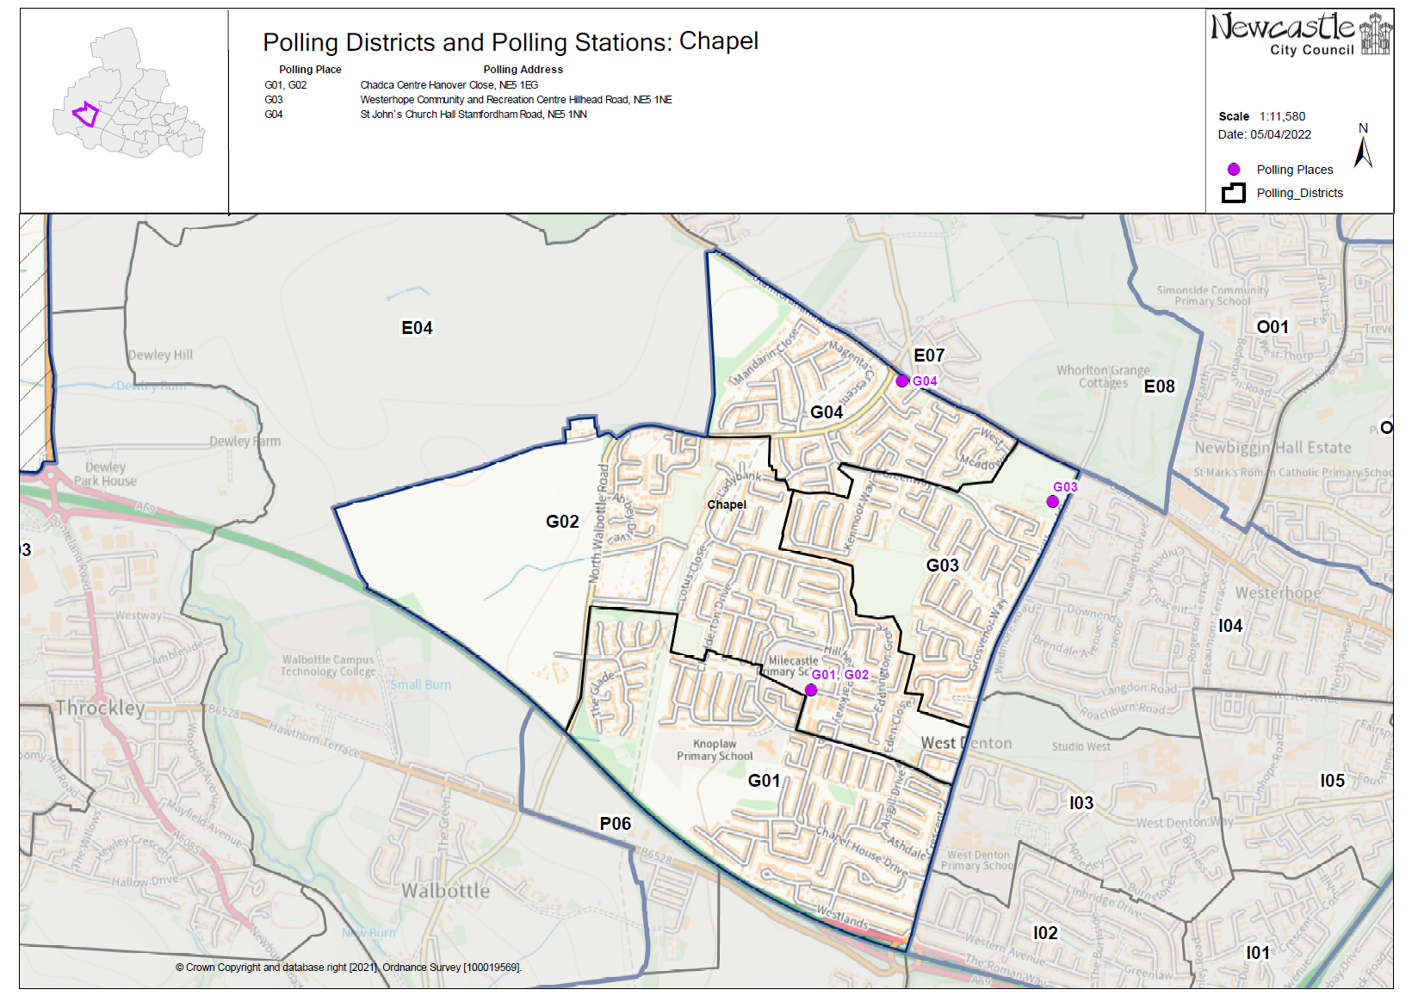

**(New)**

**Chapel Ward**

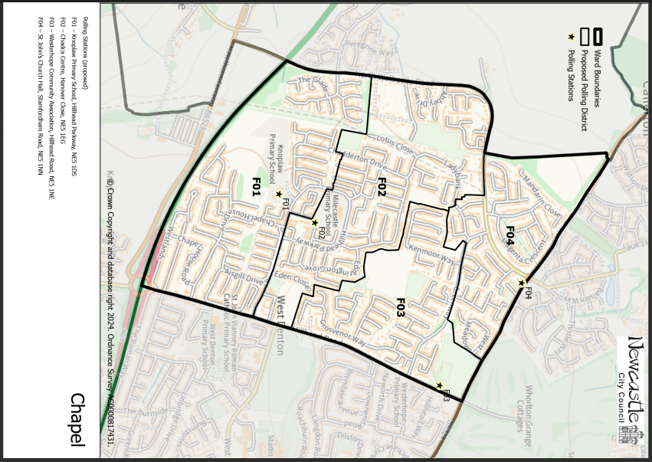This map shows the new ward and the proposed polling districts and the proposed polling places.

* **F01** – Knoplaw Primary School, Hillhead Parkway, NE5 1DS
* **F02** – Chadca Centre, Hanover Close, NE5 1EG
* **F03** – Westerhope Community Association, Hillhead Road, NE5 1NE
* **F04** – St John’s Church Hall, Stamfordham Road, NE5 1NN

**Chapel Ward**

**Polling District F01**

|  |  |
| --- | --- |
| **Current Polling District** | **Current Polling Place** |
| G01 (full) | Chadca Centre, Hanover Close, NE5 1EG |

|  |  |  |
| --- | --- | --- |
| **Proposed Polling District** | **Predicted**  **Polling Station Electorate** | **Proposed Polling Place** |
| F01 | 1247 | Knoplaw Primary School, Hillhead Parkway, NE5 1DS |
|  | | |

|  |
| --- |
| **Considerations and Proposals** |
| Current G01 is now the proposed F01 district. No change to the polling district boundary.  Knoplaw Primary School is in the proposed F01 district and is happy to be used, however a site visit and further discussion with the school is required to determine if this is a suitable building. If this building is not suitable, the proposal will be to use the Chadca Centre as a double station. |
|  |

|  |
| --- |
| **Preliminary Consultation – Elected Members comments and feedback** |
| Councillor Marc Donnelly does not express any concerns over using Knoplaw Primary but would be happy for Chadca to remain a double station. |

**Chapel Ward**

**Polling District F02**

|  |  |
| --- | --- |
| **Current Polling District** | **Current Polling Place** |
| G02 (full) | Chadca Centre, Hanover Close, NE5 1EG |

|  |  |  |
| --- | --- | --- |
| **Proposed Polling District** | **Predicted**  **Polling Station Electorate** | **Proposed Polling Place** |
| F02 | 1017 | Chadca Centre, Hanover Close, NE5 1EG |
|  | | |

|  |
| --- |
| **Considerations and Proposals** |
| Current G02 is now the proposed F02. The proposed district loses an area of land to the west of North Walbottle Road. This moves into the new Throckley, Walbottle and Newburn ward.  No change to the polling place. |
|  |

|  |
| --- |
| **Preliminary Consultation – Elected Members comments and feedback** |
| No comments received. |

**Chapel Ward**

**Polling District F03**

|  |  |
| --- | --- |
| **Current Polling District** | **Current Polling Place** |
| G03 (full) | Westerhope Community Association, Hillhead Road, NE5 1NE |

|  |  |  |
| --- | --- | --- |
| **Proposed**  **Polling District** | **Predicted**  **Polling Station Electorate** | **Proposed**  **Polling Place** |
| F03 | 743 | Westerhope Community Association, Hillhead Road, NE5 1NE |
|  | | |

|  |
| --- |
| **Considerations and Proposals** |
| Current G03 is now the proposed F03. No change to the polling district boundary.  No change to the polling place.  Westerhope Community Association is suggested as a double polling station for the proposed districts of F03 and H04. |
|  |

|  |
| --- |
| **Preliminary Consultation – Elected Members comments and feedback** |
| No comments received. |

**Chapel Ward**

**Polling District F04**

|  |  |
| --- | --- |
| **Current Polling District** | **Current Polling Place** |
| G04 (full) | St John’s Church Hall, Stamfordham Road, NE5 1NN |

|  |  |  |
| --- | --- | --- |
| **Proposed Polling District** | **Predicted**  **Polling Station Electorate** | **Proposed Polling Place** |
| F04 | 467 | St John’s Church Hall, Stamfordham Road, NE5 1NN |
|  | | |

|  |
| --- |
| **Considerations and Proposals** |
| Current G04 is now the proposed F04. No change to the polling district boundary.  No change to the polling place. |
|  |

|  |
| --- |
| **Preliminary Consultation – Elected Members comments and feedback** |
| No comments received. |